Section 1: Case Summary

Scenario Title: | 8yo M with Upper Airway Obstruction from Sausage
Keywords: | Pediatrics; airway
Brief Description of Case: | 8 y/o boy with upper airway obstruction from sausage. When indirect treatment fails, removal with Magill forceps under direct visualization is required. The patient slowly recovers after removal of foreign body but will require admission for monitoring.

Goals and Objectives
Educational Goal: | To review the management of Upper Airway Obstruction in a Child
Objectives:  (Medical and CRM) | CRM: Effectively lead a Pediatric resuscitation  - Recognize upper airway obstruction in a pediatric patient  - Apply the upper airway obstruction algorithm  - Rapidly initiate maneuvers to remove the foreign body  - Re-assesses the response to therapy  - Respiratory Distress (LOC, RR, O2 saturations, WOB)  - Implement effective communication strategies during team management:  - Task Delegation & Closed Loop Communication  - Constructive Intervention & Mutual Respect  - Thinking out loud & summarizing  - Include parent(s) in the room during resuscitation
EPAs Assessed: | C1  Resuscitating and coordinating care for critically ill patients

Learners, Setting and Personnel
Target Learners: | ☒ Junior Learners |  | ☒ Senior Learners |  |  | ☒ Staff
 | ☒ Physicians | ☒ Nurses |  | ☒ RTs | ☒ Inter-professional
 | ☐ Other Learners:
Location: | ☒ Sim Lab |  | ☐ In Situ |  |  | ☐ Other:
Recommended Number of Facilitators: | Instructors: 1
 | Confederates: 1
 | Sim Techs: 1

Scenario Development
Date of Development: | 9th/May/2017
Scenario Developer(s): | Drs. Rob Woods & Gautam Sinha
Affiliations/Institutions(s): | University of Saskatchewan & Waitemata DHB, NZ
Contact E-mail: | Rob.woods@usask.ca
Last Revision Date: | 24th/Nov/2019
Revised By:
Version Number:

Section 2A: Initial Patient Information

- Patient Chart
Patient Name: Trevor |  |  |  | Age: 8 years | Gender: M | Weight: 30kg
Presenting complaint: Choking
Temp: 37.1ºC | HR: 140/min | BP: 80/64 |  | RR: 40/min | O₂Sat: 46% NRB | FiO₂: 100%
Cap glucose: 5.7 mmol/L |  |  |  | GCS: 3
Triage note: 8-year-old boy (30kg) brought to the ED by ambulance. History of choking on a sausage with upper airway obstruction. He was eating a sausage about 30 minutes earlier and choked. He lost consciousness with the ambulance and they were unable to visualize or remove the foreign body. He is peri-arrest on ED arrival with O2 saturations in the 40s.
Allergies: None
Past Medical History: None |  |  | Current Medications: None

Section 2B: Extra Patient Information

A. Further History
To be stated by Paramedic at bedside:
“This is Trevor. He’s an 8 year old boy who has an upper airway obstruction after choking on sausage 30 minutes ago. Initially we thought he would be able to cough it out because his stridor was intermittent, but in the last 10 minutes the stridor has been persistent and we have been unable to make any progress despite doing abdominal thrusts. His saturations have crashed in last couple minutes and I am worried he is going to arrest!”
B. Physical Exam
List any pertinent positive and negative findings
Cardio: Tachycardia, pale | Neuro: Non-reactive pupils
Resp: Tachypneic with weak respiratory effort, audible stridor, crackles and wheezes in chest right side > left side | Head & Neck: Normal
Abdo: NA | MSK/skin: NA
Other: NA

Section 3: Technical Requirements/Room Vision

A. Patient
☒ Mannequin: Non-computerized, child. Realism: Conceptual
☐ Standardized Patient
☐ Task Trainer
☐ Hybrid
B. Special Equipment Required
Laryngoscope, Video Assisted Laryngoscope, ET Tubes
LMA
Scalpel, Cricothyroidotomy Kit
Magill Forceps
Capnography

C. Required Medications
Paralytics ie rocuronium
Sedation ie ketamine

D. Moulage
Child-sized mannequin to be used. Place a tube-like foreign body in the upper airway for removal.

E. Monitors at Case Onset
☒ Patient on monitor with vitals displayed
☐ Patient not yet on monitor
F. Patient Reactions and Exam
Include any relevant physical exam findings that require mannequin programming or cues from patient
(e.g. – abnormal breath sounds, moaning when RUQ palpated, etc.) May be helpful to frame in ABCDE format.

Airway – Stridor
Breathing – Shallow and tachypneic
Circulation – Not responding to pain
Disability – No response to painful stimuli, weak respiratory effort
Exposure – n/a

Section 4: Confederates and Standardized Patients

Confederate and Standardized Patient Roles and Scripts
Bedside Nurse | Will be skilled and helpful. Hooks patient up to monitors, provides additional vitals if requested. Describes the patient as being in significant respiratory distress and lethargic.

Section 5: Scenario Progression

Scenario States, Modifiers and Triggers
Patient State/Vitals | Patient Status | Learner Actions, Modifiers & Triggers to Move to Next State |  | Facilitator Notes
1. Baseline State  Rhythm: Sinus tach  HR: 140/min  BP: 80/64  RR: 40/min  O₂SAT: 46% NRB  T: 37.1ºC  GCS: 3 | Stridor, weak respiratory effort, low GCS | Expected Learner Actions  IV access/labs, monitors  Determine weight (weigh, measure length or use age based formula)  Recognition of respiratory failure from upper airway obstruction  Prepares plans (A, B, C) for removal of foreign body, communicates plan to team  Communicates treatment plan with family | Modifiers  - With direct visualization, the sausage will be visible and removable with Magill forceps – Stridor will disappear once foreign body removed
2. FB Removed  FB removed, stridor gone  HR: 140  BP: 87/61  O₂SAT: 80% NRB  RR 45 | Persistent low GCS | Expected Learner Actions  Assist ventilation to improve oxygenation  Notes slight improvement in resp status, auscultation of lungs (crackles/wheezes)  Asks for CXR  Consider inhaled salbutamol | Modifiers  - O2 saturations will slowly improve to high 90s over a few minutes  - GCS will be persistently low
3. Monitor Response to Therapy  HR: 120  BP: 98/65  O2: 99% NRB  RR: 35 | Pupils reactive, starting to have some spontaneous movements | Expected Learner Actions  Debates need for intubation (airway protection, need for bronchoscopy, need for transfer to PICU  Prepares for intubation  Consults PICU  Interprets CXR | Modifiers  -Patient will continue to improve neurologically
4. Disposition  HR: 110  BP: 98/65  O2: 98% with NP  RR: 32 | Localizing painful stimuli, spontaneous coughing | Expected Learner Actions  Determine that intubation is not necessary  Prepare for transfer  Communicate with family the disposition plan

Appendix A: Laboratory Results

None given during case

Appendix B: ECGs, X-rays, Ultrasounds and Pictures

Paste in any auxiliary files required for running the session. Don’t forget to include their source so you can find them later!

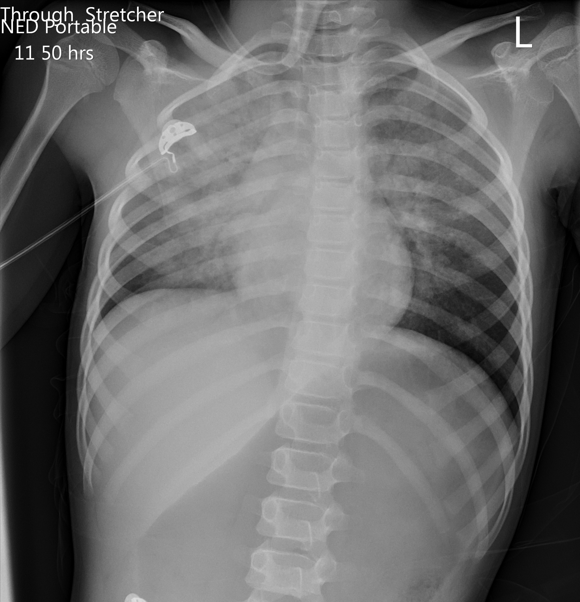

Appendix C: Facilitator Cheat Sheet & Debriefing Tips

Key Take Home Points:
- The ideal intervention:
  - Direct visualization with a laryngoscope
  - Removal with Magill forceps
  - Post-resuscitation care
- The key to managing pediatric resuscitation is good crisis resource management. Health care providers are heightened by the stakes of the case…nobody wants to see a child have a poor outcome.
  - Be clear with your tasks – use names, give only 1-2 tasks at a time, ask to be told when task complete
  - Respect all suggestions – thank suggestions and briefly explain if you choose not to follow a suggestion
  - Summarize and explain choices so everyone knows your thinking and can make suggestions appropriately
- BLS management of foreign body removal is all ‘indirect’, as described in steps above. If this is not possible (friable, liquid), then
  - Try to get access to the lungs from below the obstruction (cricothyrotomy)
  - Push the foreign body down one lung with an endotracheal tube, pull the endotracheal tube back a few cm’s and ventilate the other lung from above. (Last option and will still require bronchoscopy to ultimately remove the FB)

Epidemiology and Recognition:
- Children <5 years account for >90% deaths from foreign body aspiration; All age children = 65% deaths
- Most common cause of chocking in infants = liquids
- Most common causes of foreign body airway obstruction (FBAO) in children = balloons, small objects, and foods (e.g. hot dogs, round candies, nuts and grapes).
- Signs of FBAO: sudden onset of respiratory distress with coughing, gagging, stridor (high-pitched) or wheezing.
- FBAO is distinguishable from other resp causes (eg, croup): A) sudden onset in a proper setting and B) absence of antecedent fever or respiratory symptoms.

Relief of FBAO: FBAO may cause mild or severe airway obstruction.
- Mild – do not interfere. Allow the victim to clear the airway by coughing while you observe for signs of severe FBAO.
- Severe (victim may not be unable to make a sound):
  - Infant: Deliver 5 back blows followed by 5 chest thrusts repeatedly until the object is expelled or the patient becomes unresponsive. Abdominal thrusts are not recommended because they damage the large and relatively unprotected liver.
  - Child: perform subdiaphragmatic abdominal thrusts (Heimlich) until the object is expelled or patient unresponsive.
  - Unresponsive: Preform CPR but look into the mouth before giving breaths. If you see a foreign body, remove it. DO NOT perform blind finger sweeps – may push obstructing objects further into the pharynx and may damage the oropharynx.

Prompting questions:
- Did you feel that your team leader had control over the room? Did he or she ask for input?
- How do you manage foreign body airway obstruction?
- What are the advanced techniques available for foreign body removal beyond BLS? What do you do if you can’t remove it?

References

1. https://canadiem.org/crackcast-e168-pediatric-respiratory-emergencies-upper-airway-obstruction-and-infections/
2.
3.

